**On-Demand Car Wash**

**Low Level Design**

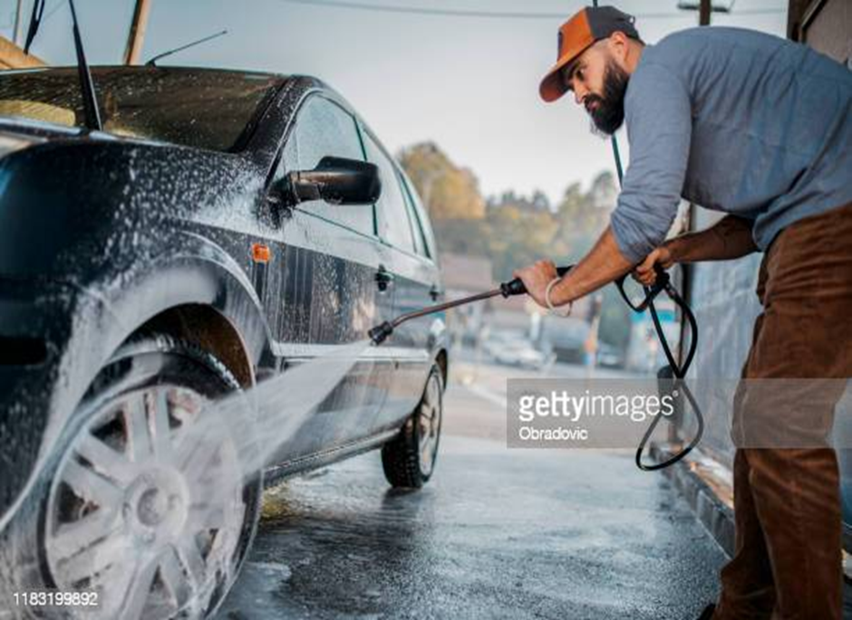

**SHRIJA SHERI**

**BATCH:4**



**Table of Contents**

**1.0 Objective………………………………………….**

**2.0 About the Project……………………………..**

**3.0 Roles………………………………………………..**

**4.0. Software Requirements……………………..**

**5.0 Hardware Requirements…………………..**

**6.0. Features ………………………………………….**

**7.0 Design Pattern…………………………………**

**8.0 Use Case Diagram…………………………….**

**9.0 Activity Diagram………………………………**

**10.0 Database Tables…………………..………….**

**11.0 Class Diagrams…………………………………**

**12.0 ER Diagram………….……………………...…**

**13.0 Architectural Diagram ………..…….……**

**14.0 Solution Diagram………………..……………**

**15.0 Classes and Functions……………………….**

**1.0.OBJECTIVE:**

Online media consumption has grown dramatically during the last several years ,Mobile smartphone have replaced other digital devices as the primary platform for practically all services .

With only a few touches on mobile device,we may use any service without having to wait or stand in huge lines.The same is true for on-demand vehicle wash services ; customers can avoid lengthy queues by simply using an

On-Demand Car Wash App.

**2.0.About the Project:**

In today’s world, the concept of the On-Demand car wash app is becoming very popular among peoples. If someone wishes he/she can have his / her car washed, the long queues can be avoided, the time spent on booking the service and waiting for your turn can be let go by installing one on-demand car wash mobile app which will be your ultimate solution. The On-Demand idea has offered many fans of startups. Here we’ll focus on the how to make on-demand car wash mobile app and cost of app development for android & ios platforms.  
  
With on-demand service apps doing well, on-demand car wash mobile apps are gaining strong business and car owners are using these personalized car washing apps to get the services delivered at the right locations. The cost of on-demand car wash app development depends on the choice of mobile platforms, the position of your app development team, and the number of features you wish to add to your own app.

**3.0.ROLES:**

* Customer
* Car washer
* Admin

**4.0.Software Requirements:**

* Operating System -Windows
* Frontend – Angular
* Middleware – Web API
* Backened – SQL Server
* Tools Used- Visual Studio and SSMS

**5.0.HardWare Requirements:**

* Processor – Core i5
* Primary Memory – 8 Gb
* Hard Disk - 6Gb free space

## 6.0.Feature-Rich On Demand Car Wash App Solutions

## Customer App

Start your on-demand car wash app development journey with us to craft a brand out of your business that ensures tech-stability and constant support necessary for your business to succeed.

### User Profile

Every user who installs the program has the option of creating a user profile with a personalized name and personal information in the car wash app.

### Book A Wash

Users may arrange a vehicle wash based on their current location. The reservation can be made for immediate usage or scheduled at a later date.

### Preferred Date & Time

Set your desired data and time for vehicle wash services ahead of time. It aids in the proactive planning of recurrent services.

### Cancel Request

Users have the option to cancel previously placed vehicle wash orders. The requests might be postponed to a later date or cancelled immediately.

### Push Notifications

Every booking, whether approved or denied, will be sent to the user via push notifications.

### Locations

Create unique addresses and preferred places on the built-in map to make it simpler to discover car wash services.

## Washer App

The registered washers get login and password to help push user notification on delivery and accept washing requests with our car wash app.

### Washer Profile

Washers may establish their own profiles, replete with the services they offer, their availability, unique services, and so on.

### Add Location

Washers can add numerous locations to their services to make it easier for clients to discover on-demand car wash services near their current location.

### Upcoming Washes

A bird's-eye view of forthcoming washes, special client requests, projected revenue per wash, and so on.

### Notifications

The washer will be notified of a new vehicle wash request made by the administrator.

### Before & After Photo

Washers may demonstrate their effectiveness in providing wash services by uploading before and after vehicle wash photos.

### Payment Request

When the wash is finished, the washer can seek payment from the admin. He can request money for a variety of services.

### Rating & Reviews

Washers may provide evaluations and ratings for consumers to identify the best and worst customers.

## Admin Panel

Manage real-time user and washers payment with our car wash app development services.

### User Registration

Admin can control users by reviewing their profiles, social network handles, and other information.

### Car Wash Request

Manage vehicle wash requests proactively by prioritizing idle washers.

### Car Wash History

The admin may look up vehicle wash history from the dashboard to verify payments, service frequency, and efficiency.

### Create Plans

Admin of the car wash app can build customized price plans based on the nature of the services provided, the duration of the plan, the location, and so on.

### Washer Payout

Admin confirms the services and releases money to the washer's bank account after receiving the payment request from the washer

### Manage Ratings

If necessary, the administrator can monitor the star ratings and reviews submitted by users and manage any harmful behaviour.

### Email and SMS notification

Admins may setup email settings to send email and SMS notifications for each important activity performed with the app.

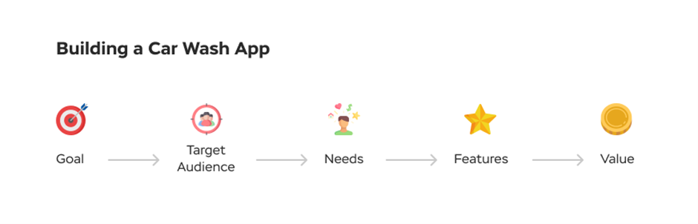

**7.0.DESIGN PATTERN:**

|  |  |  |
| --- | --- | --- |
| S.No | NAME | DESCRIPTION |
|  |  |  |
| 1 | Angular | By using this we will develop the user interface |
| 2 | Ado.Net Core | It acts as a bridge between Frontened control & |
|  |  | the Backened Database |
| 3 | c# | C# can be used to create a number of different |
|  |  | programs and applications |
| 4 | (Database)SQL | Databases are used for storing,maintaining |
|  |  | and accessing any sort of data.Here we are |
|  |  | using SQL Server Database. |
| 5 | Entity Framework | It is a technique of accessing a relational |
|  |  | Database |

**8.0.USE CASE DIAGRAM:**

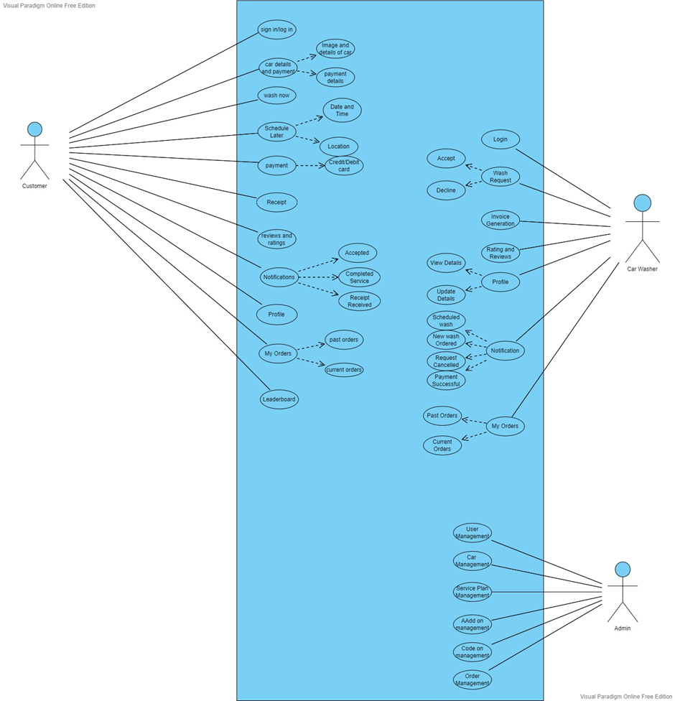

**9.0.ACTIVITY DIAGRAM:**

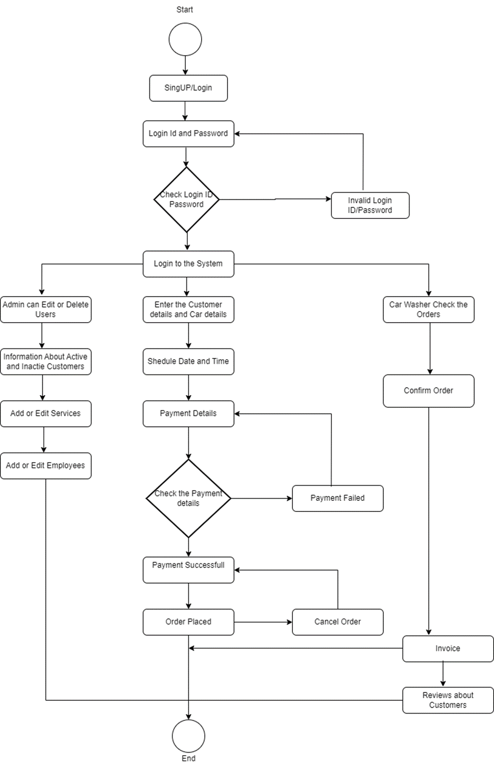

**10.0.DATABASE TABLES:**

|  |  |  |  |
| --- | --- | --- | --- |
| User Profile | | | |
| Keys | Details | Datatype | Validations |
| PK | Id | int | Unique |
|  | FirstName | varchar(20) | not null |
|  | LastName | varchar(20) | not null |
|  | Phone Number | int | not null |
|  | Email | varchar(20) | unique |
|  | Password | char(20) | unique |
|  | Role(Customer/Washer) | varchar(50) | not null |

|  |  |  |  |
| --- | --- | --- | --- |
| Admin | | | |
| Keys | Details | Datatype | Validations |
| PK | ID | int | not null |
|  | Email | varchar(20) | unique |
|  | Password | char(32) | unique |
|  |  |  |  |

|  |  |  |  |
| --- | --- | --- | --- |
| Order | | | |
| Keys | Details | Datatypes | validation |
| PK | Id | int | not null |
| FK | PackageId | int | not null |
| FK | AddressId | int | not null |
|  | Washing Instructions | varchar(50) | null |
|  | Date of wash | DATETIME | not null |
|  | Status | varchar(50) | not null,check (status = Accepted or Rejected or Ongoing or Pending |
| FK | CustomerId | int | not null |

|  |  |  |  |
| --- | --- | --- | --- |
| Package | | | |
| Keys | Details | Datatypes | Validation |
| PK | Id | int | not null |
|  | Name | varchar(20) | not null |
|  | Description | varchar(50) | null |
|  | Price | decimal | not null,,check(price>0 & price<10000) |
|  | Status | varchar(20) | not null |

|  |  |  |  |
| --- | --- | --- | --- |
| Promocode | | | |
|  | Details | Datatypes | Validations |
|  | Id | Int | unique |
|  | Name | varchar(20) | not null |
|  | Discount | decimal | not null,check(discount>0 & discount<70) |
|  | Status | varchar(50) | not null |

|  |  |  |  |
| --- | --- | --- | --- |
| Car | | | |
| Keys | Details | Datatype | Validations |
| PK | Id | int | not null |
|  | Model | varchar(20) | not null |
|  | Status | varchar(20) | not null |

|  |  |  |  |
| --- | --- | --- | --- |
| Address | | | |
| Keys | Details | Datatype | Validations |
| FK(user Id) | Id | int | not null |
|  | City | varchar(20) | not null |
|  | State | varchar(20) | not null |
|  | PinCode | int | not null |
| PK | AddressId | int | not null |

**11.0.CLASS DIAGRAM:**

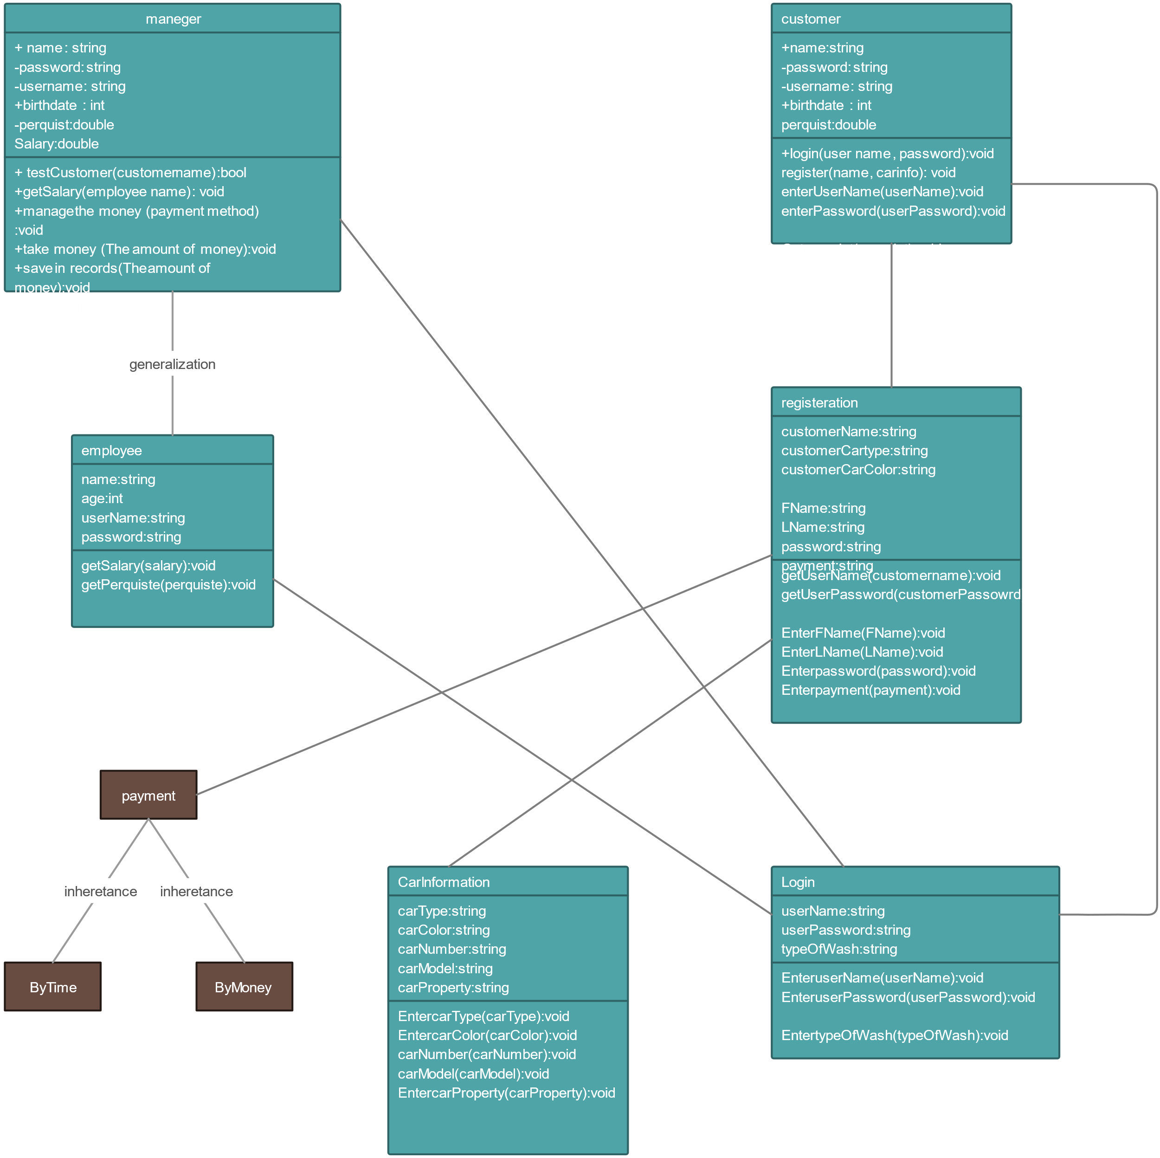

**12.0.ER DIAGRAM:**

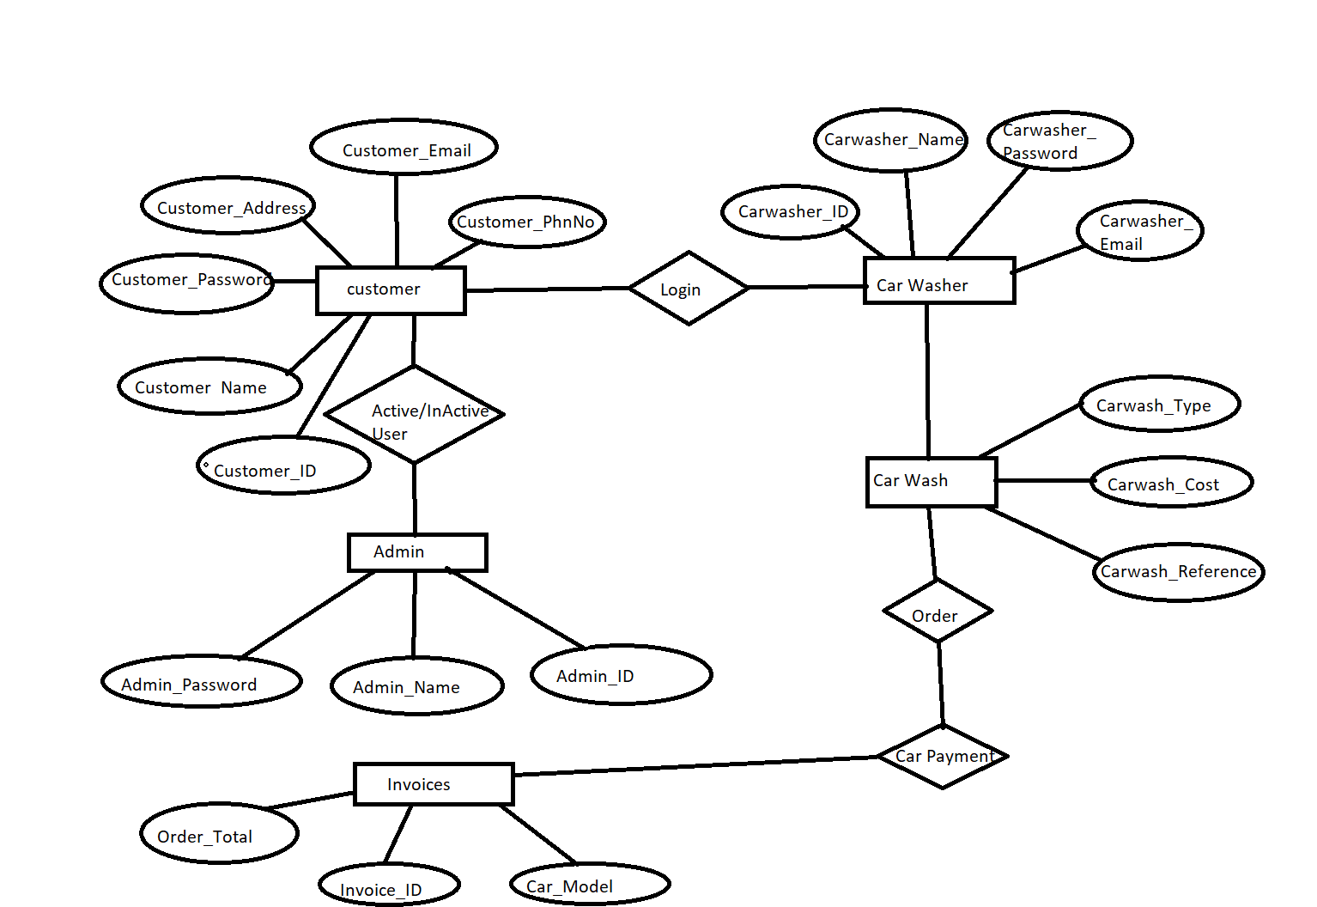

**13.0.ARCHITECTURAL DIAGRAM:**

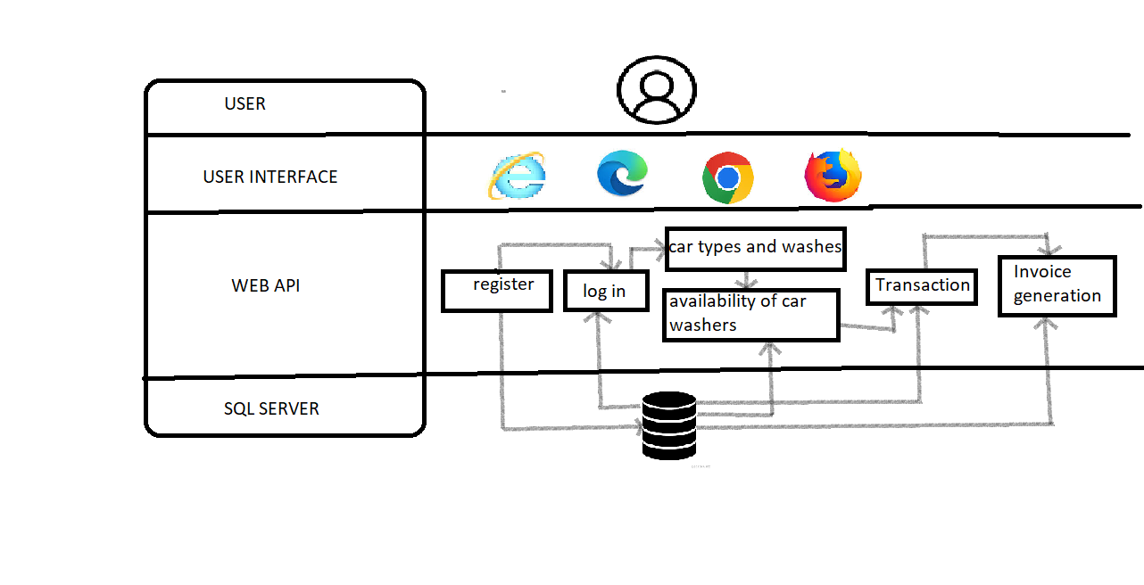

**14.0.SOLUTION DIAGRAM:**

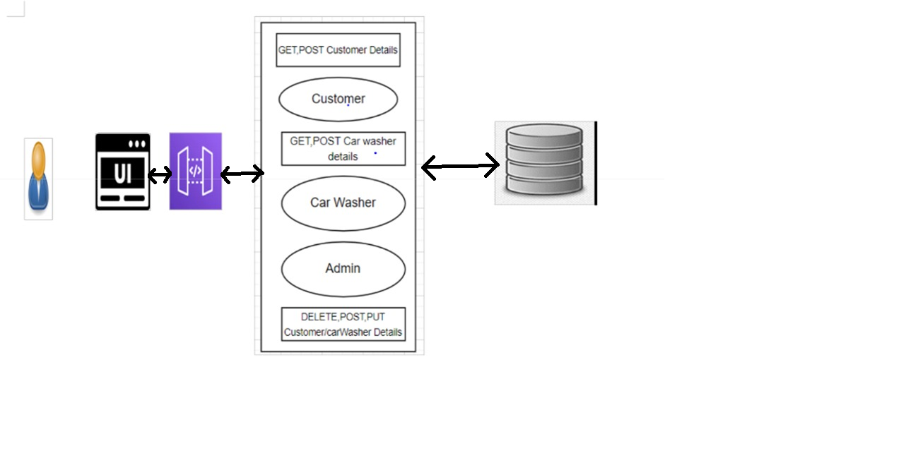

**15.0.CLASSES AND FUNCTIONS**

|  |  |  |
| --- | --- | --- |
| S.no | Class | Description |
| 1 | Customer | Model holds the customers deatails |
| 2 | registerCustomerHandler | The handler to handle the registration of |
|  |  | customers which calls the registerCustomer |
|  |  | Service class |
| 3 | CarWasher | Model holds the car washer details |
| 4 | WashType | This model contains the what type of wash did |
|  |  | customer requires |
| 5 | Admin | Model holds admin details |
| 6 | Payment | It contains thre core business logic for the |
|  |  | payment method of customers |
| 7 | Cost | This class deals with the cost maintained for |
|  |  | wash. |